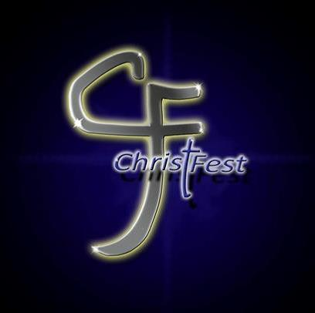
Christ Fest 2017 Community Choir Informational Letter

April 2017

Dear Pastor or Music Minister,
It’s that time of year again! Planning for Christ Fest 2017 is in full swing! We are praying that we see even more churches in the city of Muncie and the surrounding area get involved this year. We hope that you will share this information with members in your church that may be interested in participating.
One opportunity for you and your congregation to participate is the Christ Fest Community Choir. Ministering with the Community Choir over the last few years has been a blast, and it did not require a big time commitment for practices! We want to make it clear that those that participate in the choir do not need to be talented singers. They just need to have a heart to worship the Lord.
Anyone 12 years of age and older is welcome to participate. We will have four rehearsals that will take place at Tabernacle of Praise, 2200 E. Fuson Rd., Muncie, IN. Rehearsals are tentatively scheduled for Monday evenings at 6PM on 8/21, 8/28, 9/4, and 9/11. Christ Fest this year will take place at the Delaware County Fairgrounds with a youth night on Friday, September 15th from 6PM – 10PM and the main event on Saturday, September 16th from
12PM – 10PM. The choir will be opening up the event on Saturday the 16th at 12PM.
If you have any questions, you can contact me at 765-766-2091. God is doing great things, and I cannot wait to lift up the powerful name of Jesus with you all at Christ Fest 2017!

Sincerely,
Sis. Amy Brooks
Worship Pastor, Tabernacle of Praise

